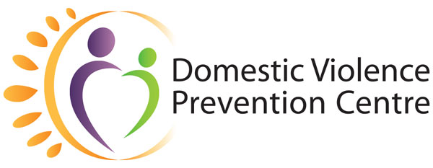
Domestic Violence Prevention Month

May 2021 | Social Campaign

Week Four (16–28 May):
How to help

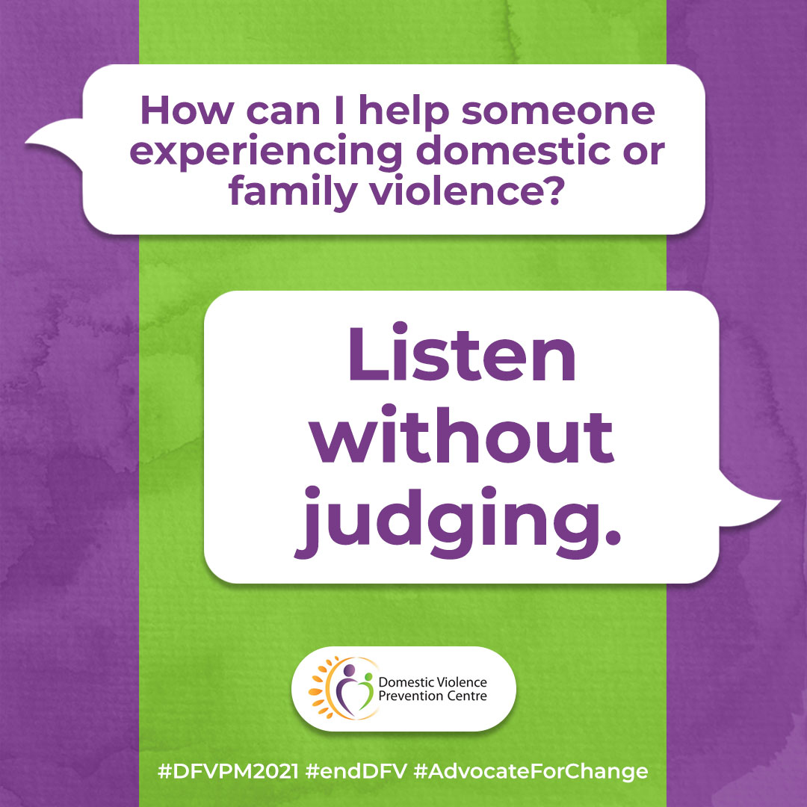
Accompanying text:
How can I help someone experiencing domestic or family violence?

Listen without judging.
For many women, friends and family are often the first people they talk to about domestic violence. It takes a lot of time, planning, help and courage to escape domestic violence. It is important for women to know that help is available from people who know and care about the situation.
Tell your friend that you care and are willing to listen. If she is willing to talk, listen carefully and empathically in a safe place. Believe her. Never blame her for what's happening or under estimate her fear of danger. Let her know that no one deserves to be abused, beaten or threatened.
For more information, visit https://domesticviolence.com.au/information/supporting-someone/
How to get help:
In an emergency phone the police on Triple Zero (000)
For free counselling, support, information and referral for women and their children who have or are experiencing domestic and family violence, call DVPC (9am–5pm, Monday to Friday) on (07) 5591 4222.
#DFVPM2021 #endDFV #AdvocateForChange

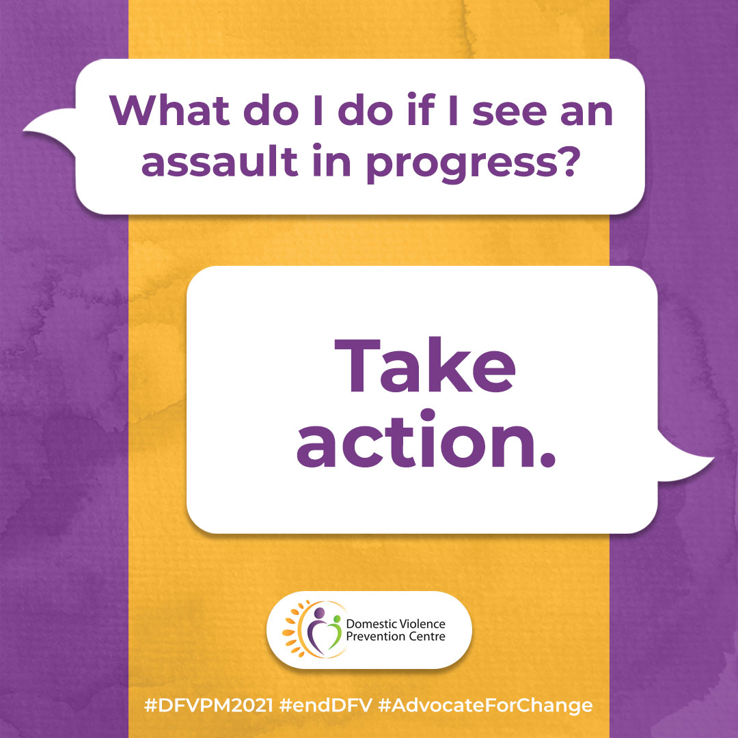
Accompanying text:
What do I do if I see an assault in progress?

If you see an assault in progress, take action.
Call the police on triple zero (000). Don't assume that someone else has done so. If you are in your car honk your horn until a group gathers, he stops hitting her or the police come. These situations can be dangerous so whatever you do be sure to keep yourself safe. But do take action. At the very least, watch them. Being a witness in a way that lets him know that you see him may reduce his level of violence.
For more information, visit https://domesticviolence.com.au/information/supporting-someone/
How to get help:
In an emergency phone the police on Triple Zero (000)
For free counselling, support, information and referral for women and their children who have or are experiencing domestic and family violence, call DVPC (9am–5pm, Monday to Friday) on (07) 5591 4222.
#DFVPM2021 #endDFV #AdvocateForChange

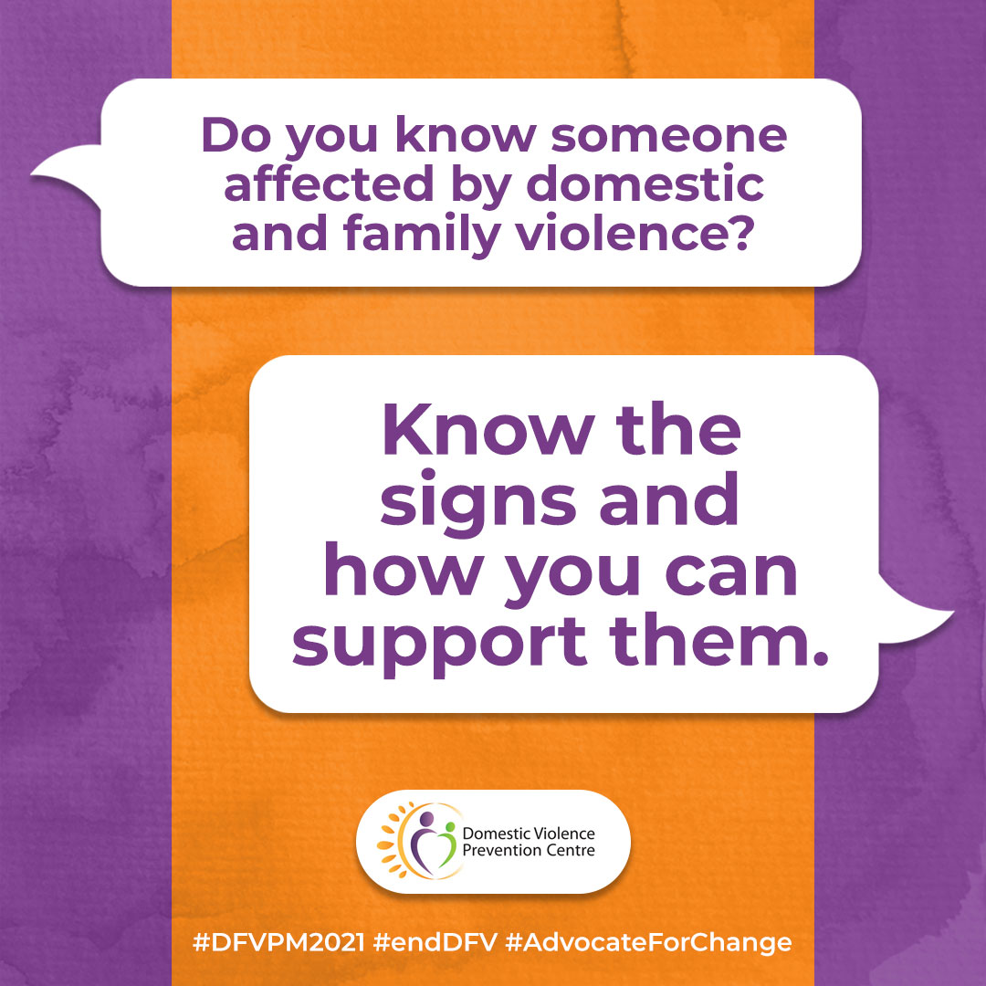
Accompanying text:
Do you know someone affected by domestic and family violence?

Know the signs and how you can support them.
Chances are someone you know - your neighbour, co-worker, friend, sister or mother is a victim of domestic and family violence. The following are some signs that might alert you that someone you know may be affected by domestic and family violence:
- She may have bruises or injuries or she has frequent "accidents" for which she gives vague explanations. These "accidents" sometimes cause her to miss work.
- Her partner controls her activities, the family's finances, the way she dresses or her contact with friends and family.
- She frequently cancels plans at the last minute or seems afraid of making her partner angry.
- Her partner ridicules her publicly or you sense volatility in his comments.
• Her partner seems overly attentive, remains constantly by her side or is watchful about who she talks to.
- You notice changes in her or her children's behaviour. She appears frightened or exhausted.
Perhaps you feel her problem will "work itself out". Not so, domestic and family violence doesn't usually end unless action is taken to stop it. But it can be hard to know what to do. People are often reluctant to discuss something so intimate and they're afraid of intruding.
For more information, visit https://domesticviolence.com.au/information/supporting-someone/
How to get help:
In an emergency phone the police on Triple Zero (000)
For free counselling, support, information and referral for women and their children who have or are experiencing domestic and family violence, call DVPC (9am–5pm, Monday to Friday) on (07) 5591 4222.
#DFVPM2021 #endDFV #AdvocateForChange

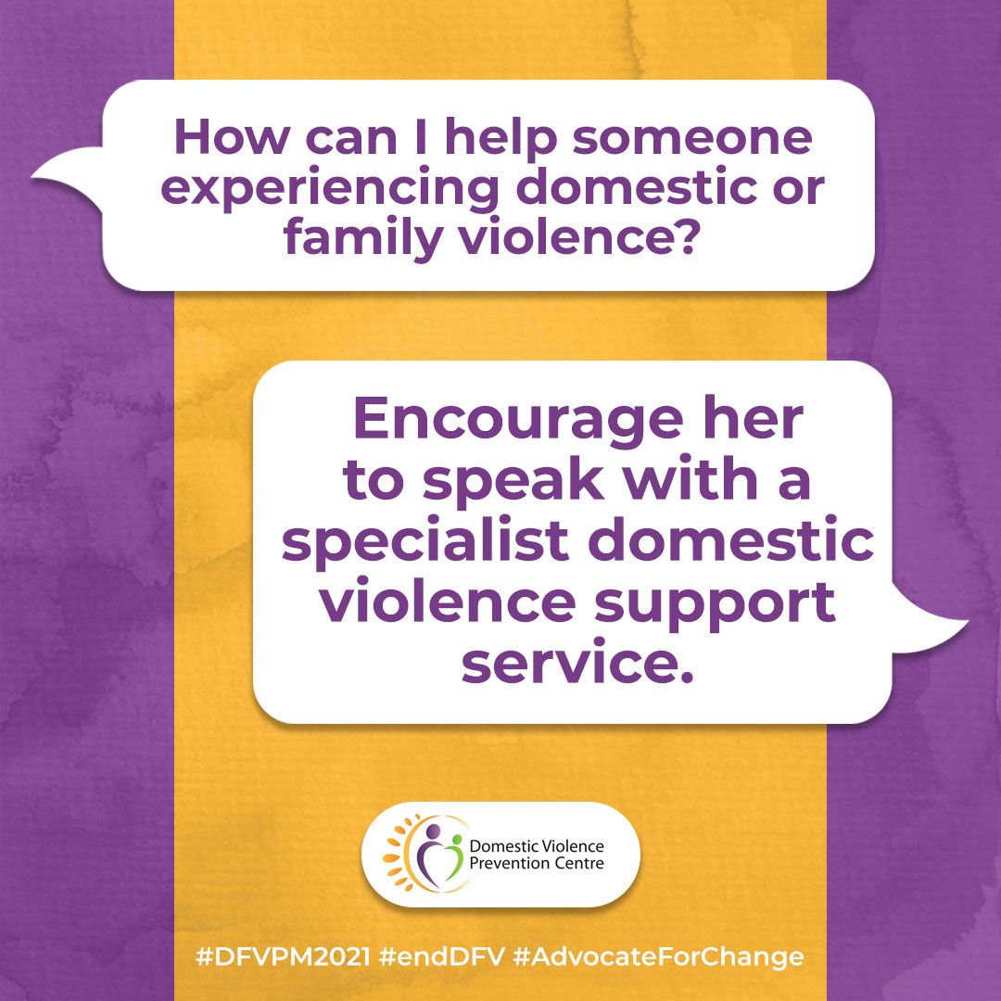
Accompanying text:
How can I help someone experiencing domestic or family violence?

Encourage her, and if she wants, support her to speak to a specialist domestic violence support service.
Many women who have found freedom describe someone they knew (a neighbour, doctor, friend) offering support and referring them to a support service. Let her know she is not alone, and that people are available to help her. Assure her that they will keep information about her confidential.
Many women first seek the advice of marriage counsellors, psychiatrists, church and others. Unfortunately, not all helping professionals are fully aware of the complexities of domestic violence and the safety issues she faces. If the first person she contacts is not helpful, encourage her to speak to the Domestic Violence Prevention Centre Gold Coast Inc.
For more information, visit https://domesticviolence.com.au/information/supporting-someone/
How to get help:
In an emergency phone the police on Triple Zero (000)
For free counselling, support, information and referral for women and their children who have or are experiencing domestic and family violence, call DVPC (9am–5pm, Monday to Friday) on (07) 5591 4222.
#DFVPM2021 #endDFV #AdvocateForChange

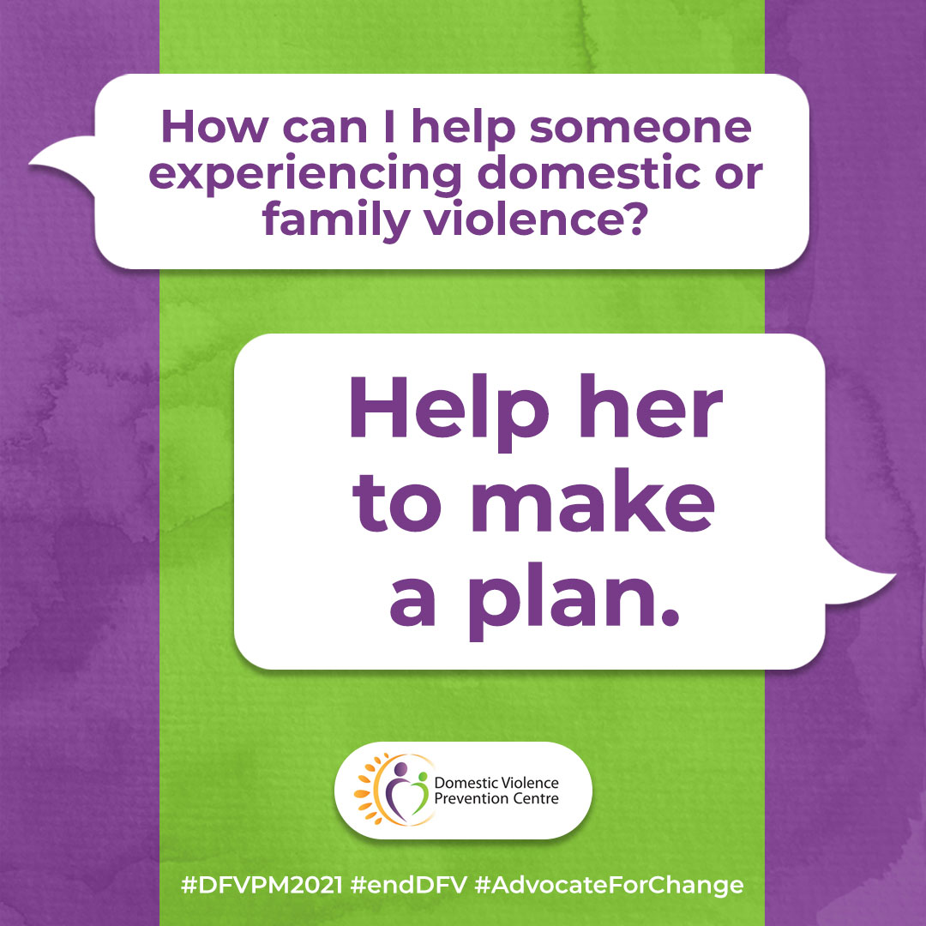
Accompanying text:
How can I help someone experiencing domestic or family violence?

Help her to make a plan.
Your friend may decide to remain in the violent relationship or return to the abuser after a temporary separation. Don't pressure her to leave but let her know that you are afraid for her and her children and help her consider how dangerous the violence may be.
Encourage her to speak to a specialist DV service where they can be supported to develop a safety plan that works for her. Help her think about steps she can take if her partner becomes abusive again. Make a list of people to call in an emergency. Suggest she gathers copies of important documents and phone numbers. Acknowledge that she may be in the most danger while she's trying to leave.
For more information, visit https://domesticviolence.com.au/information/supporting-someone/
How to get help:
In an emergency phone the police on Triple Zero (000)
For free counselling, support, information and referral for women and their children who have or are experiencing domestic and family violence, call DVPC (9am–5pm, Monday to Friday) on (07) 5591 4222.
#DFVPM2021 #endDFV #AdvocateForChange

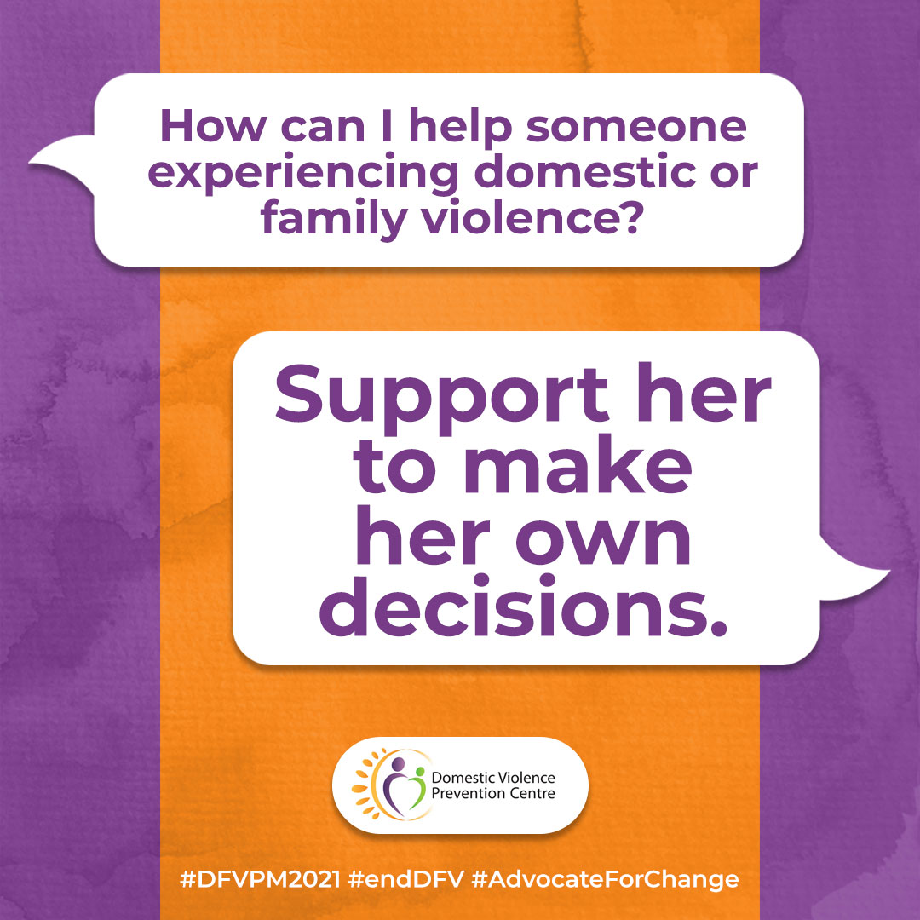
Accompanying text:
How can I help someone experiencing domestic or family violence?

Support her to make her own decisions.
Acknowledge that she is the expert about her life, needs and wants. As you listen try to understand the many obstacles that prevent her from leaving. It's usually very complex. Focus on supporting her in making her own decisions. If she is being abused then he is exercising a lot of control over her life. It is very important she is encouraged to make choices for herself even if it means staying with the abuser for now.
It is often the first step towards freedom. Even if she leaves him and then goes back, don't withdraw your support.
For more information, visit https://domesticviolence.com.au/information/supporting-someone/
How to get help:
In an emergency phone the police on Triple Zero (000)
For free counselling, support, information and referral for women and their children who have or are experiencing domestic and family violence, call DVPC (9am–5pm, Monday to Friday) on (07) 5591 4222.
#DFVPM2021 #endDFV #AdvocateForChange

