Domestic Violence Prevention Month

May 2021 | Social Campaign

Week Three (15–21 May):
Myths and facts

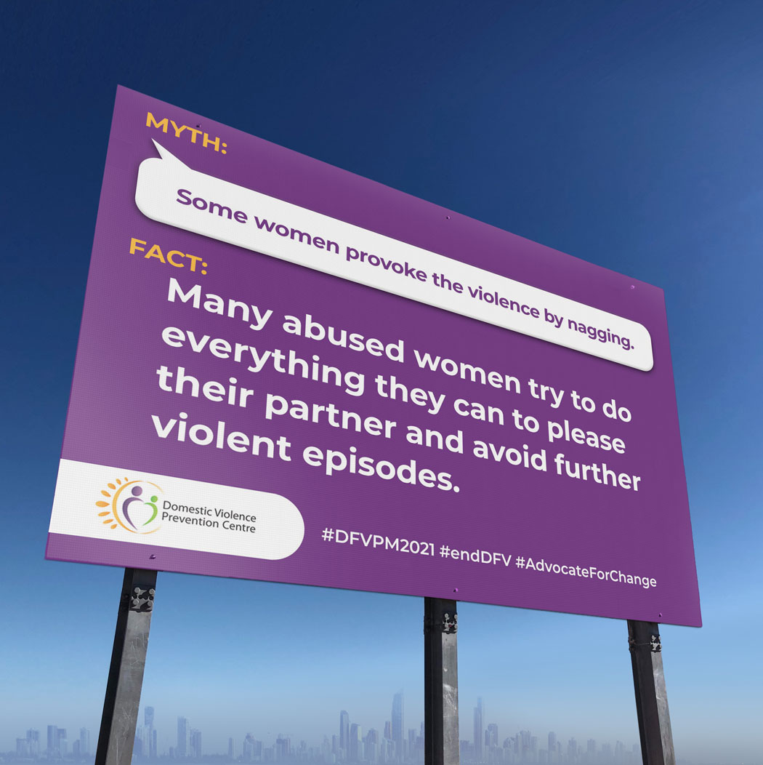
Myth

Some women provoke the violence by nagging.
Fact
Most abused women try to do everything they can to please their partner and avoid further violent episodes. Victims of domestic violence are vulnerable to further episodes of abuse regardless of their behaviour. Responsibility for violence rests solely with the abuser.
For more information, visit https://domesticviolence.com.au/information/myths-and-facts/
How to get help:
In an emergency phone the police on Triple Zero (000)
For free counselling, support, information and referral for women and their children who have or are experiencing domestic and family violence, call DVPC (9am–5pm, Monday to Friday) on (07) 5591 4222.
#DFVPM2021 #endDFV #AdvocateForChange

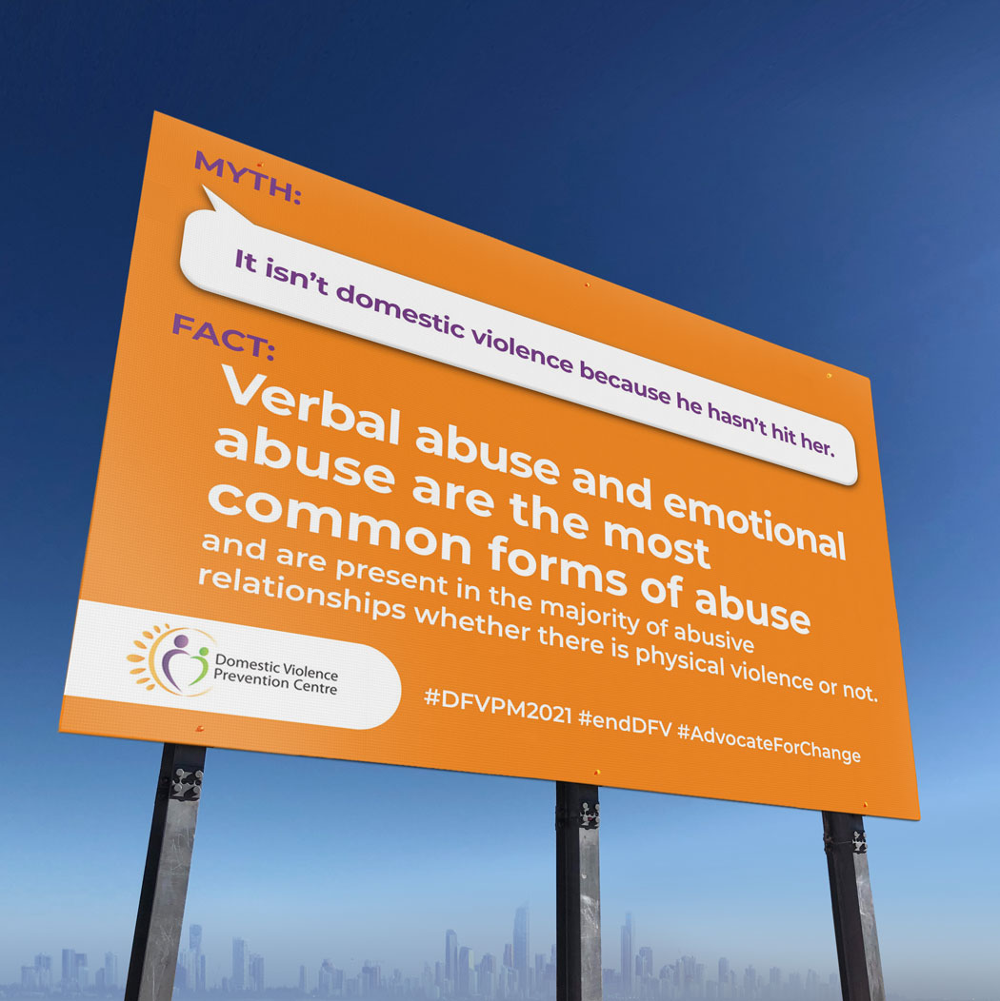

Myth

It isn’t domestic violence because he hasn’t hit her.
Fact
Verbal abuse and emotional abuse are the most common forms of abuse and are present in the majority of abusive relationships whether there is physical violence or not.
Abusers use words and other behaviours to control, to intimidate and to cause fear in their victim. These forms of abuse can cause significant harm, impacting negatively on her self-confidence and her self-esteem.
The damage caused by verbal and emotional abuse often lasts long after the relationship has ended.
For more information, visit https://domesticviolence.com.au/information/myths-and-facts/
How to get help:
In an emergency phone the police on Triple Zero (000)
For free counselling, support, information and referral for women and their children who have or are experiencing domestic and family violence, call DVPC (9am–5pm, Monday to Friday) on (07) 5591 4222.
#DFVPM2021 #endDFV #AdvocateForChange

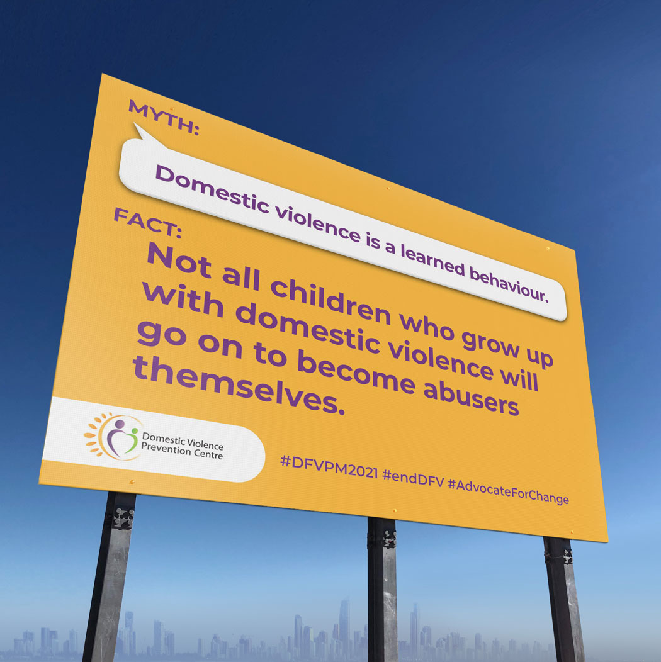

Myth

Domestic violence is a learned behaviour.
Fact
Abusers have often witnessed domestic violence as children. However not all children who grow up with domestic violence will go on to become abusers themselves. Likewise not all perpetrators of domestic violence grew up in violent homes.
Violence is a choice. In our society there is widespread tolerance of gender, racial, religious and cultural inequality and violence. This teaches that abuse and controlling behaviour is acceptable.
However, abuse that is learned can be un-learned and positive. Healthy ways of relating can be learned.
For more information, visit https://domesticviolence.com.au/information/myths-and-facts/
How to get help:
In an emergency phone the police on Triple Zero (000)
For free counselling, support, information and referral for women and their children who have or are experiencing domestic and family violence, call DVPC (9am–5pm, Monday to Friday) on (07) 5591 4222.
#DFVPM2021 #endDFV #AdvocateForChange

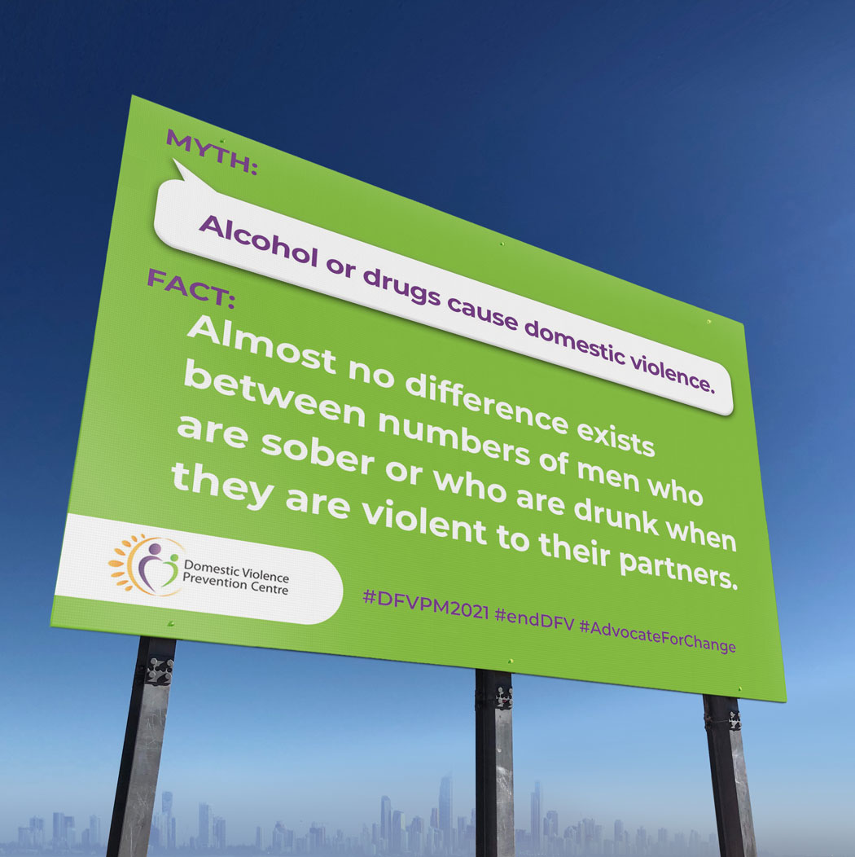
Myth

Alcohol or drugs cause domestic violence.
Fact
It is a misconception that domestic violence is caused directly by alcohol or substance abuse.
The fact is almost no difference exists between numbers of men who are sober or who are drunk when they are violent to their partners. Where studies show that more drinkers are violent to their partners, the studies are not able to explain why many drunken men (80% heavy and binge drinkers) do not abuse their partners.
Alcohol or other addictive substances are used by men as a means to give themselves permission to be violent. If someone blames alcohol or drugs they are avoiding taking responsibility for their actions - many people enjoy drinking and some may even drink excessively but they never use violence. Many people stop their drinking and still keep using violence and controlling behaviours.
While the use of alcohol and drugs can often make the violence more serious, it does not cause it. Domestic violence takes place in a context of coercive control and in response to threats to male dominance to maintain control over females.
For more information, visit https://domesticviolence.com.au/information/myths-and-facts/
How to get help:
In an emergency phone the police on Triple Zero (000)
For free counselling, support, information and referral for women and their children who have or are experiencing domestic and family violence, call DVPC (9am–5pm, Monday to Friday) on (07) 5591 4222.
#DFVPM2021 #endDFV #AdvocateForChange

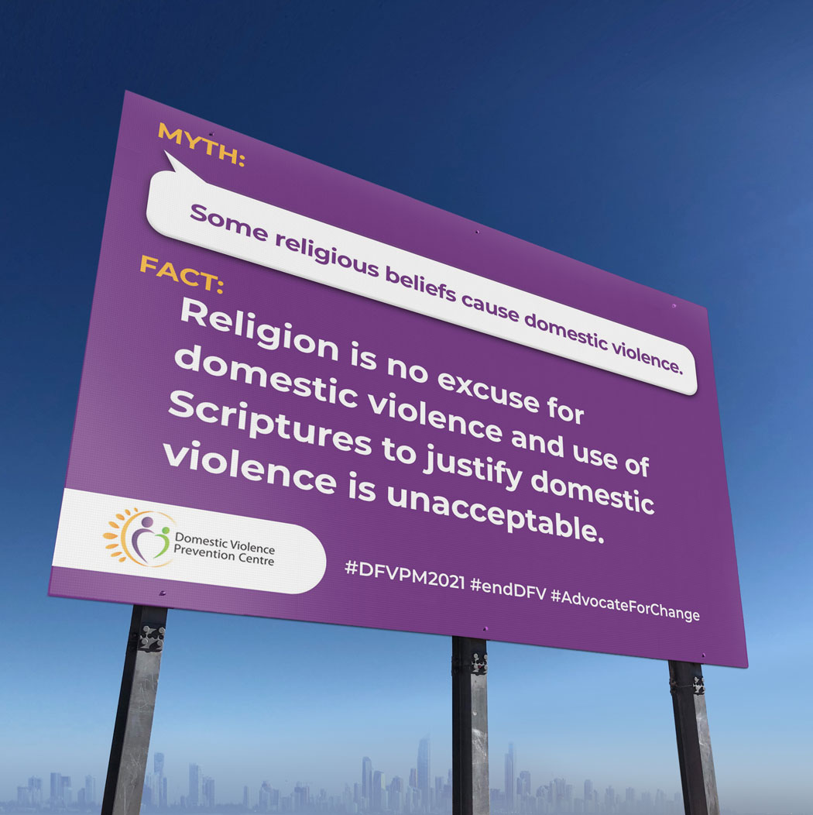
Myth

Some religious beliefs cause domestic violence.
Fact
Some abusers may use religion as an excuse for their violence.
Religion is no excuse for domestic violence and use of Scriptures to justify domestic violence is unacceptable. There is nothing to support the view that it is God's will for people to endure domestic and family violence. Some women may feel pressure from their faith or church community to 'honour' their commitment to marriage and stay in the abusive relationship. Leaving or getting a divorce is against their religious beliefs.
“The Scriptures can sometimes be misused to condone the use of power and to keep women and children in unsafe situations. Hence care offered by the church has often been destructive rather than liberating”.
Ian George, Archbishop of Adelaide 1995
For more information, visit https://domesticviolence.com.au/information/myths-and-facts/
How to get help:
In an emergency phone the police on Triple Zero (000)
For free counselling, support, information and referral for women and their children who have or are experiencing domestic and family violence, call DVPC (9am–5pm, Monday to Friday) on (07) 5591 4222.
#DFVPM2021 #endDFV #AdvocateForChange

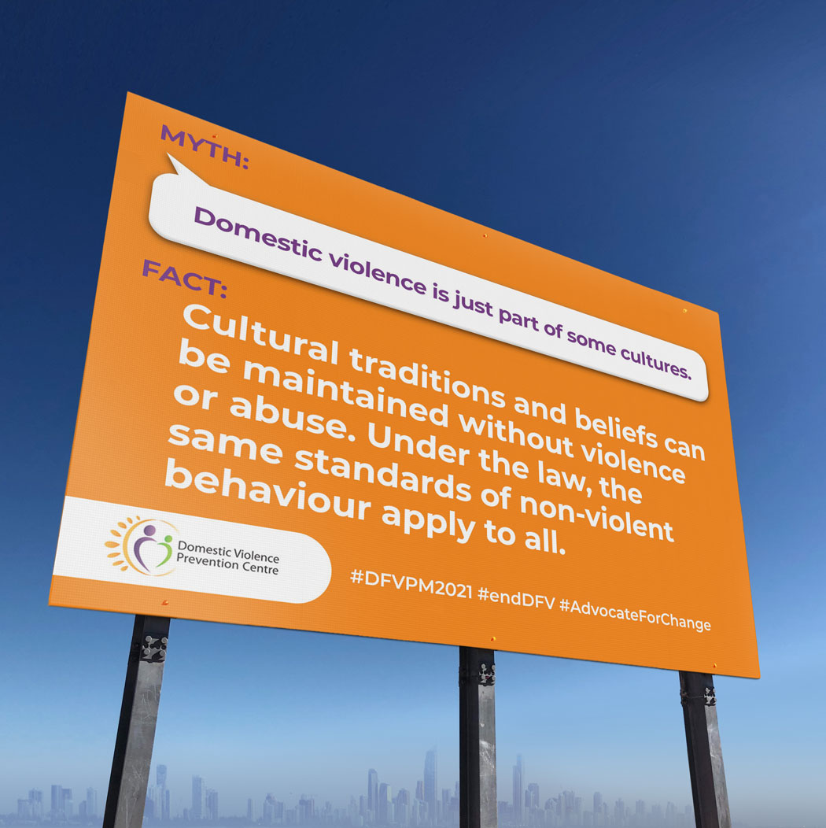

Myth

Domestic violence is just part of some cultures.
Fact
Domestic violence crosses all countries and cultures. Some abusive men claim that in their culture women have a subordinate role and the use of violence is permitted to keep women in line. Some accuse the legal system of attempting to destroy their culture or say that laws against family violence are racist. It is important to maintain cultural traditions and beliefs, but this can be done without violence or abuse. Under the law the same standards of non-violent behaviour apply to all.
For more information, visit https://domesticviolence.com.au/information/myths-and-facts/
How to get help:
In an emergency phone the police on Triple Zero (000)
For free counselling, support, information and referral for women and their children who have or are experiencing domestic and family violence, call DVPC (9am–5pm, Monday to Friday) on (07) 5591 4222.
#DFVPM2021 #endDFV #AdvocateForChange

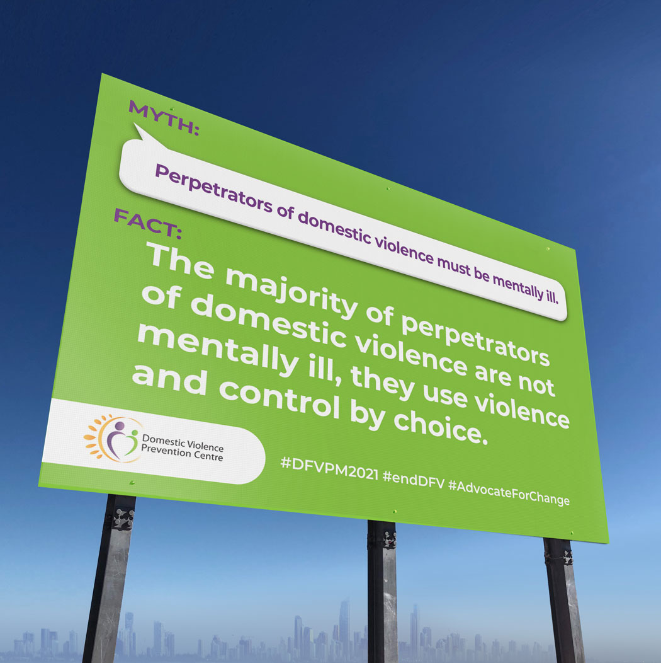
Myth

Sexual assault offenders are mentally ill.
Fact
The majority of sexual offenders are not mentally ill. Mental illness does not cause people to sexually offend. Many sex offenders are functioning people in the community, they have jobs, are married, have children.
The media often seem to focus on sex offenders who fit the stereotype; they are selective in who they choose to report on. This only helps to maintain the silence on sexual assault. This makes it difficult for people to believe that someone who doesn’t fit that profile could commit sexual offences.*
*Source: https://qsan.org.au/myths-facts/
For more information, visit https://domesticviolence.com.au/information/myths-and-facts/
How to get help:
In an emergency phone the police on Triple Zero (000)
For free counselling, support, information and referral for women and their children who have or are experiencing domestic and family violence, call DVPC (9am–5pm, Monday to Friday) on (07) 5591 4222.
#DFVPM2021 #endDFV #AdvocateForChange

