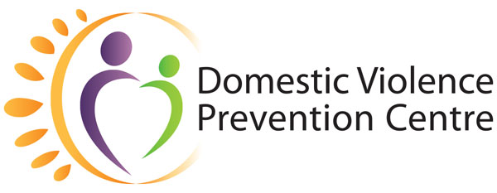
Domestic Violence Prevention Month

May 2021 | Social Campaign

Week Two (2–14 May):
What is domestic and family violence?

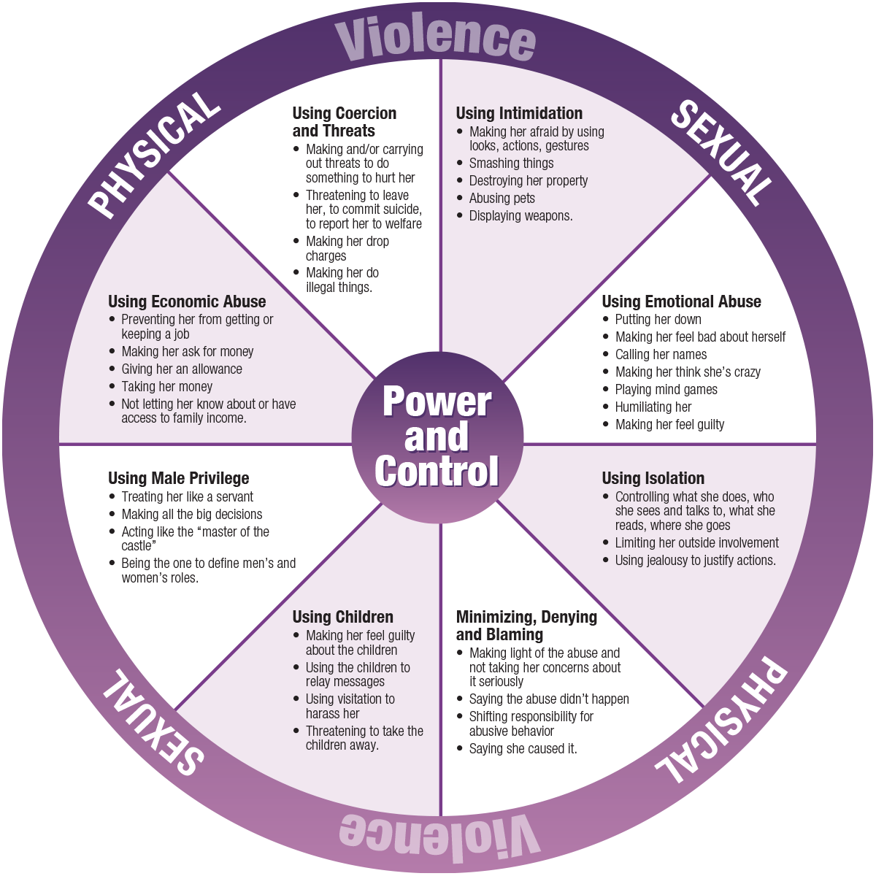

What is domestic and family violence?
Accompanying text:
No one ever deserves to experience abuse. Everyone deserves to feel safe and respected in their relationships.
Domestic and family violence generally occurs as a pattern of behaviours that are linked by power and control. This means that one person in the relationship intentionally and deliberately rules by fear, suppresses the others free will, intimidates, coerces and threatens to or actually does harm to the other, as a way and means to control or have power over them.
Power and Control is at the centre of the Wheel*. Each spoke of the Wheel represents a particular tactic which may be used by the person who is using control. The rim of the Wheel that holds it together is actual and threatened physical and sexual violence.
* Domestic Abuse Intervention Project
202 East Superior Street, Duluth, MN, 55802
218-722-2781
For more information, visit https://domesticviolence.com.au/information/#power
How to get help:
In an emergency phone the police on Triple Zero (000)
For free counselling, support, information and referral for women and their children who have or are experiencing domestic and family violence, call DVPC (9am–5pm, Monday to Friday) on (07) 5591 4222.
#DVPM2021 #DomesticViolencePreventionMonth #AdvocateForChange

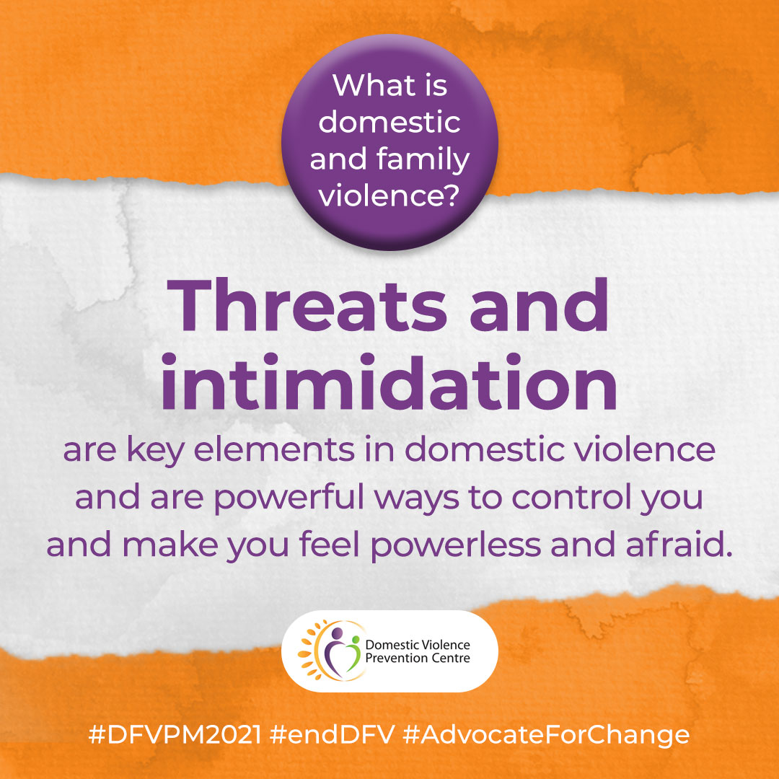
What is domestic and family violence?
Threats and intimidation are key elements in domestic violence and are powerful ways to control you and make you feel powerless and afraid.
Accompanying text:
Threats and intimidation are key elements in domestic violence and are powerful ways to control you and make you feel powerless and afraid.
This can include smashing things, destroying possessions, putting a fist through the wall, handling of guns, knives or other weapons, using intimidating body language (angry looks, raised voice), hostile questioning, or reckless driving of a vehicle. They may also threaten to commit suicide or harm or take the children.
It may also include harassing you at your workplace, persistent phone calls or sending text messages or emails, following you to and from work, or loitering near your workplace or home.
For more information, visit https://domesticviolence.com.au/information/#forms
How to get help:
In an emergency phone the police on Triple Zero (000)
For free counselling, support, information and referral for women and their children who have or are experiencing domestic and family violence, call DVPC (9am–5pm, Monday to Friday) on (07) 5591 4222.
#DVPM2021 #DomesticViolencePreventionMonth #AdvocateForChange

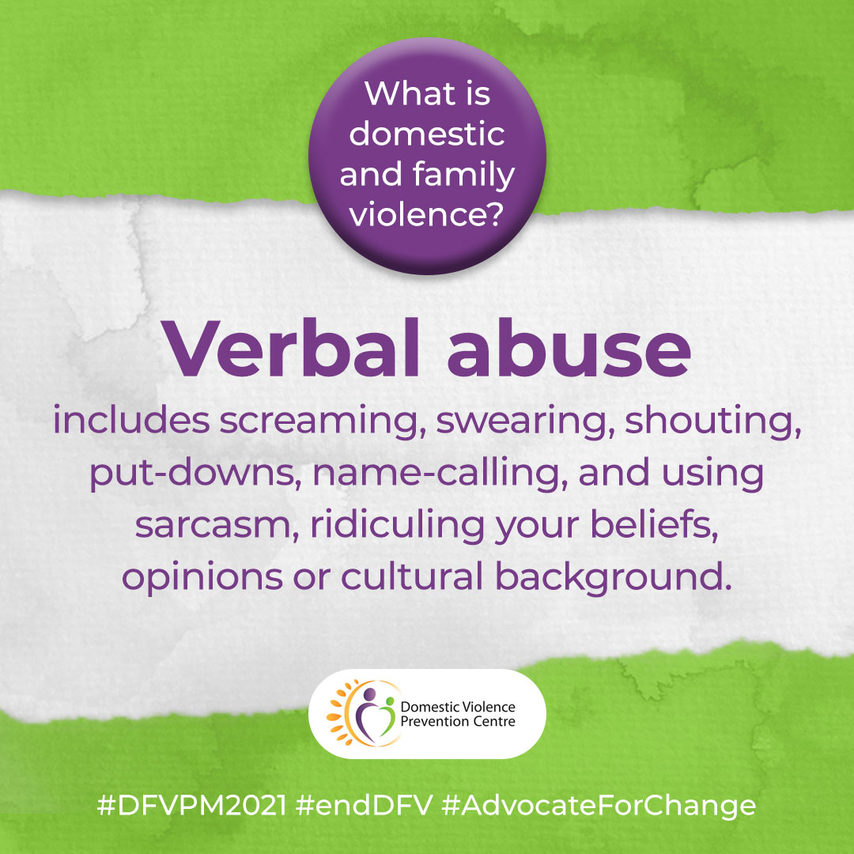
What is domestic and family violence?
Verbal abuse includes screaming, swearing, shouting, put-downs, name-calling, and using sarcasm, ridiculing your beliefs, opinions or cultural background.
Accompanying text:
Verbal abuse includes screaming, swearing, shouting, put-downs, name-calling, and using sarcasm, ridiculing your beliefs, opinions or cultural background. It is aimed at destroying your sense of self.
For more information, visit https://domesticviolence.com.au/information/#forms
How to get help:
In an emergency phone the police on Triple Zero (000)
For free counselling, support, information and referral for women and their children who have or are experiencing domestic and family violence, call DVPC (9am–5pm, Monday to Friday) on (07) 5591 4222.
#DVPM2021 #DomesticViolencePreventionMonth #AdvocateForChange

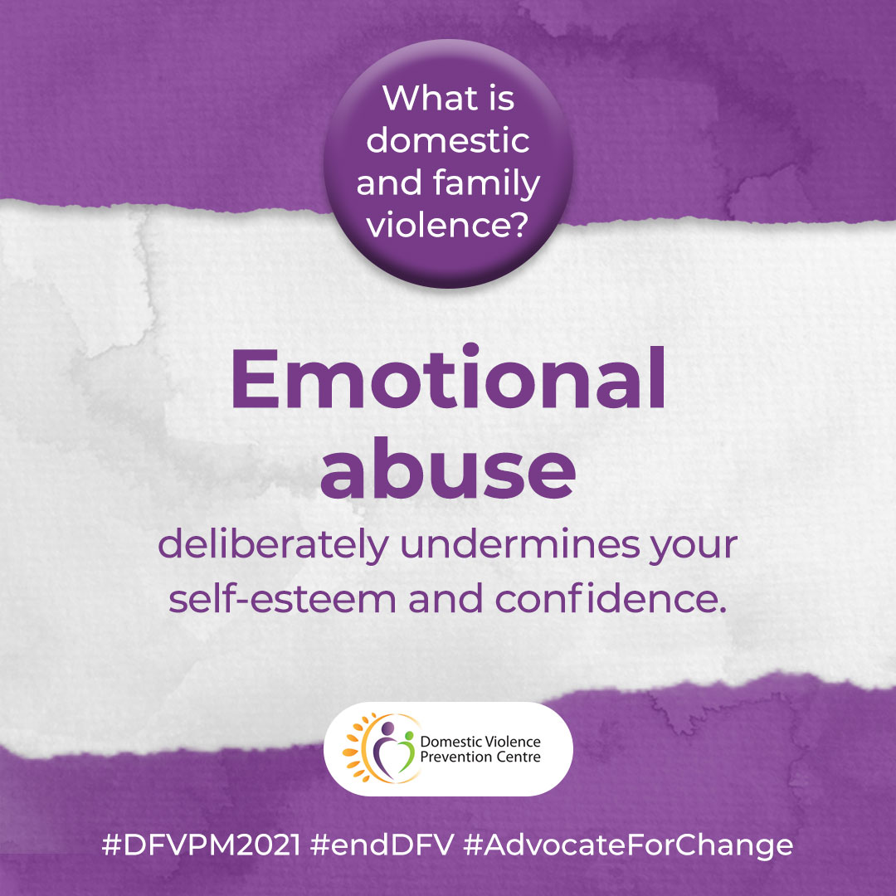
What is domestic and family violence?
Emotional abuse deliberately undermines your self-esteem and confidence.
Accompanying text:
Emotional abuse is behaviour that deliberately undermines your self-esteem and confidence, leading you to believe you are stupid, or ‘a bad mother’, useless going crazy or are insane.
Threats may include harm to you, self, children or others or silence and withdrawal as a means to abuse. This type of abuse humiliates, degrades and demeans.
For more information, visit https://domesticviolence.com.au/information/#forms
How to get help:
In an emergency phone the police on Triple Zero (000)
For free counselling, support, information and referral for women and their children who have or are experiencing domestic and family violence, call DVPC (9am–5pm, Monday to Friday) on (07) 5591 4222.
#DVPM2021 #DomesticViolencePreventionMonth #AdvocateForChange

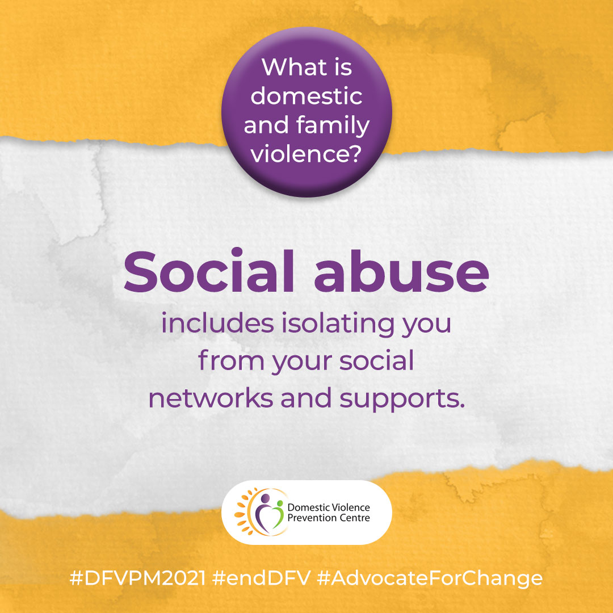
What is domestic and family violence?
Social abuse includes isolating you from your social networks and supports.
Accompanying text:
Social abuse includes isolating you from your social networks and supports either by preventing you from having contact with family or friends or by verbally or physically abusing you in public or in front of others. It may be continually putting friends and family down, so you slowly disconnect from your support network.
For more information, visit https://domesticviolence.com.au/information/#forms
How to get help:
In an emergency phone the police on Triple Zero (000)
For free counselling, support, information and referral for women and their children who have or are experiencing domestic and family violence, call DVPC (9am–5pm, Monday to Friday) on (07) 5591 4222.
#DVPM2021 #DomesticViolencePreventionMonth #AdvocateForChange

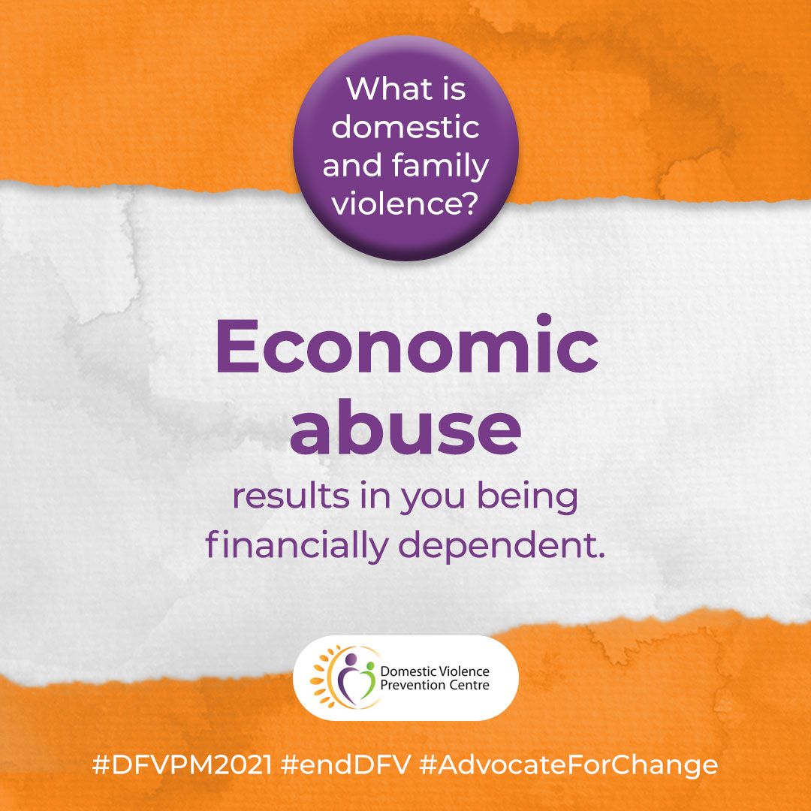
What is domestic and family violence?
Economic abuse results in you being financially dependent.
Accompanying text:
Economic abuse results in you being financially dependent. It includes being denied access to money, including your own, demanding that you and the children live on inadequate resources. It can also include being forced to sign loans and being responsible for debts that you have not incurred.
For more information, visit https://domesticviolence.com.au/information/#forms
How to get help:
In an emergency phone the police on Triple Zero (000)
For free counselling, support, information and referral for women and their children who have or are experiencing domestic and family violence, call DVPC (9am–5pm, Monday to Friday) on (07) 5591 4222.
#DVPM2021 #DomesticViolencePreventionMonth #AdvocateForChange

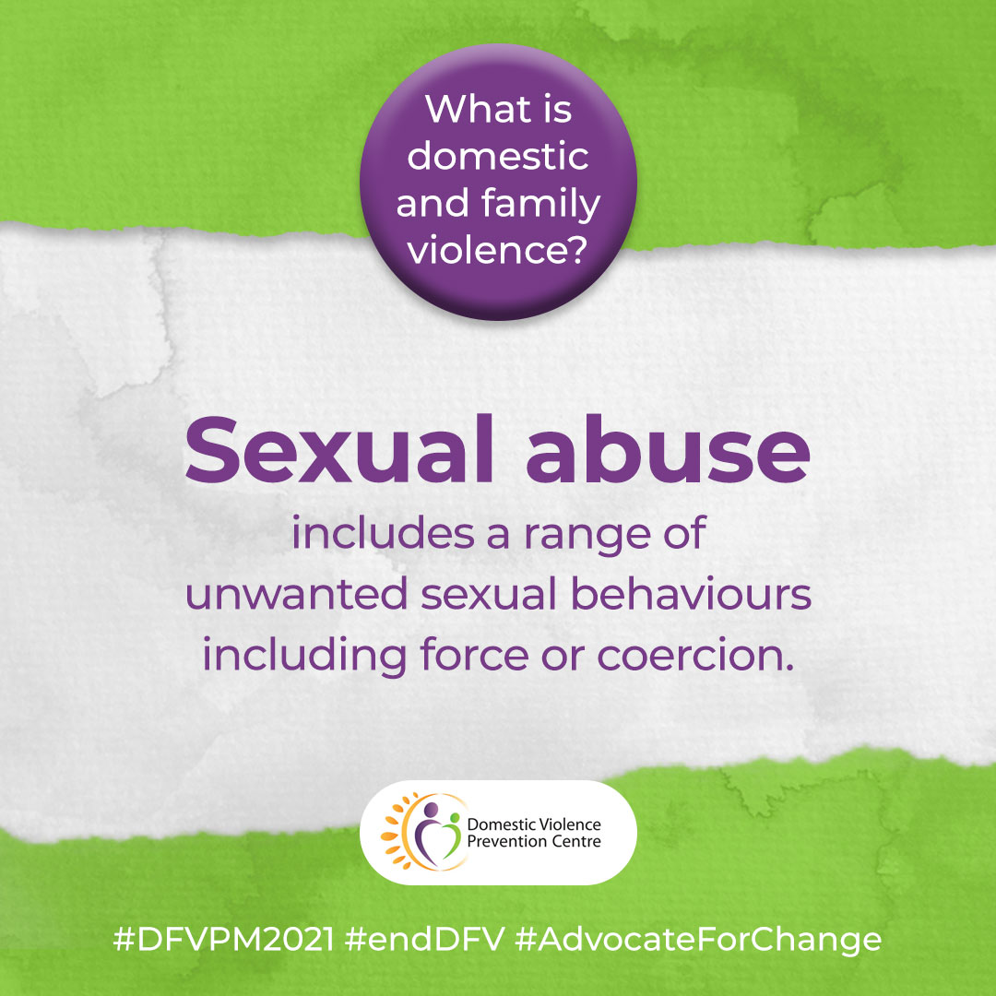
What is domestic and family violence?
Sexual abuse includes a range of unwanted sexual behaviours including force or coercion.
Accompanying text:
Sexual abuse includes a range of unwanted sexual behaviours including forcing or coercing you to watch pornography, forced sexual contact, rape, forcing you to perform sexual acts that cause pain or humiliation, forcing you to have sex with others, or causing injury to your sexual organs.
For more information, visit https://domesticviolence.com.au/information/#forms
How to get help:
In an emergency phone the police on Triple Zero (000)
For free counselling, support, information and referral for women and their children who have or are experiencing domestic and family violence, call DVPC (9am–5pm, Monday to Friday) on (07) 5591 4222.
#DVPM2021 #DomesticViolencePreventionMonth #AdvocateForChange

