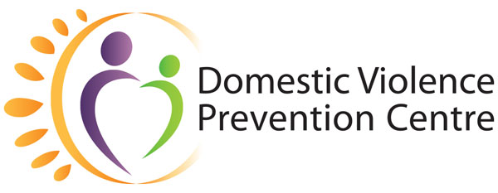
Domestic Violence Prevention Month

May 2021 | Social Campaign

Week One (1–7 May):
Domestic and family violence affects everyone

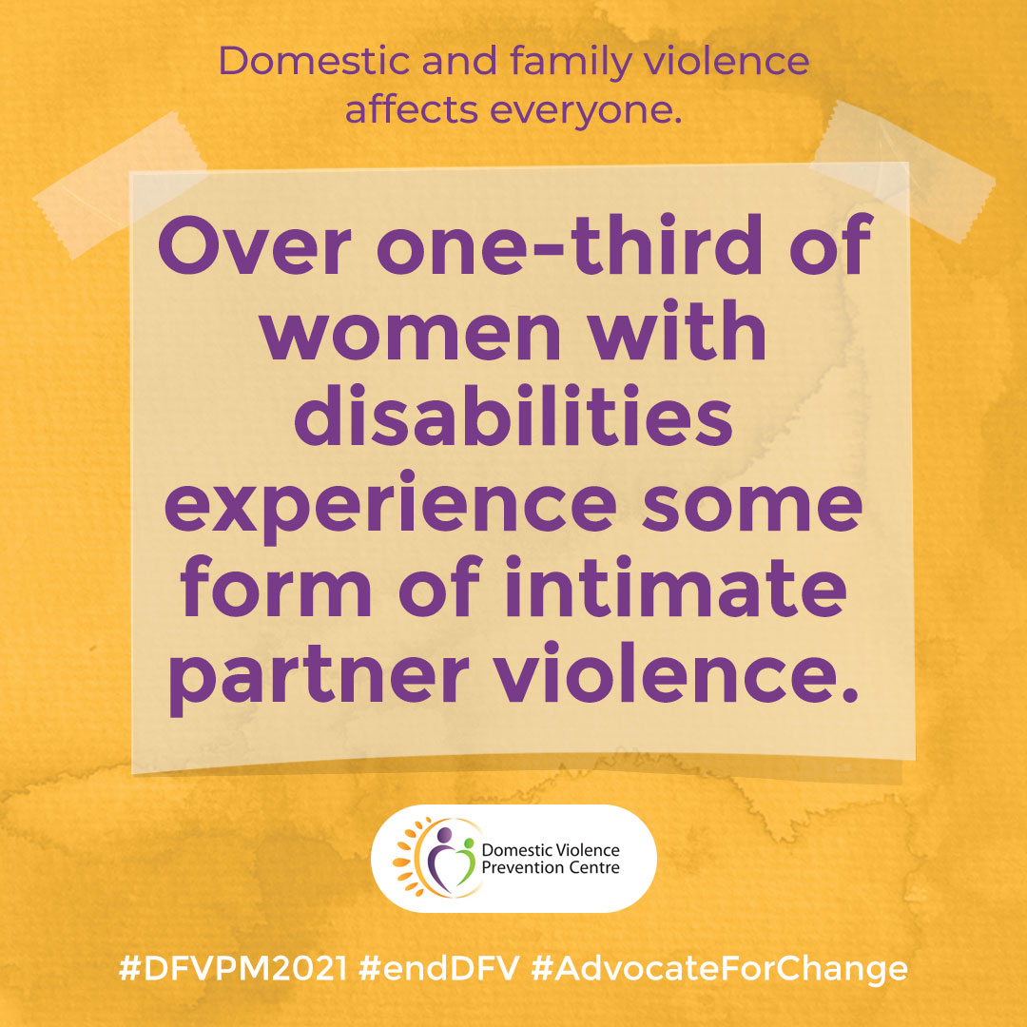

Disability
Over one-third of women with disabilities experience some form of intimate partner violence.
Accompanying text:
Over one-third of women with disabilities experience some form of intimate partner violence. *
Seeking support can be particularly complex particularly when the perpetrator is also your carer or support person. This can also make the decision to leave a violent relationship very difficult.
A specialist domestic violence service recognises and understands some of the challenges that a person with a disability who experiences domestic and family violence may face. They can provide you with support in relation to the domestic violence and assist you to link with disability support agencies and advocacy services.
*Source: https://engage.dss.gov.au/wp-content/uploads/2015/05/WDV-Fact-Sheet-3-Violence1.pdf
For more information and support, visit: https://domesticviolence.com.au/information/#disability
How to get help:
In an emergency phone the police on Triple Zero (000)
Contact the Domestic Violence Prevention Centre Gold Coast for free and confidential counselling, support, information on (07) 5591 4222.
#DVPM2021 #DomesticViolencePreventionMonth #AdvocateForChange

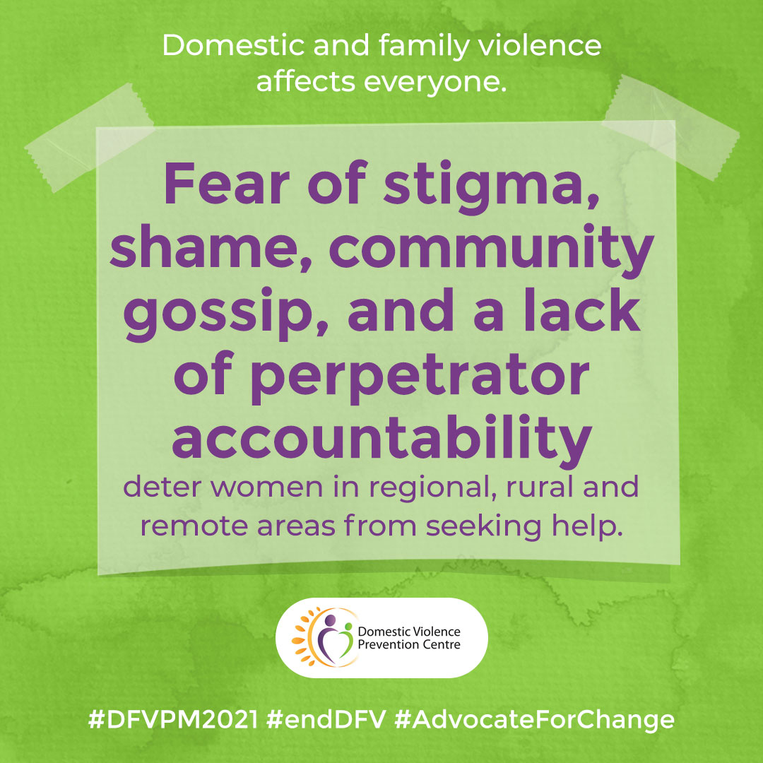

Rural
Fear of stigma, shame, community gossip, and a lack of perpetrator accountability deter women in regional, rural and remote areas from seeking help.
Accompanying text:
- Women in regional, rural and remote areas are more likely than women in urban areas to experience domestic and family violence.
- Women living in regional, rural and remote areas who experience domestic and family violence face specific issues related to their geographical location and the cultural and social characteristics of living in small communities.
- There is a common view in rural communities that "family problems" such as domestic and family violence are not talked about, which serves to silence women's experience of domestic and family violence and deter them from disclosing violence and abuse.
- Fear of stigma, shame, community gossip, and a lack of perpetrator accountability deter women from seeking help.
- A lack of privacy due to the high likelihood that police, health professionals and domestic and family violence workers know both the victim and perpetrator can inhibit women's willingness to use local services.
- Women who do seek help find difficulty in accessing services due to geographical isolation, lack of transportation options and not having access to their own income.*
*Source: https://aifs.gov.au/cfca/publications/domestic-and-family-violence-regional-rural-and-remote-communities
For more information, support and resources, visit: https://domesticviolence.com.au/information/information-about-family-violence/#family
How to get help:
In an emergency phone the police on Triple Zero (000)
Contact the Domestic Violence Prevention Centre Gold Coast for free and confidential counselling, support, information on (07) 5591 4222.
#DVPM2021 #DomesticViolencePreventionMonth #AdvocateForChange

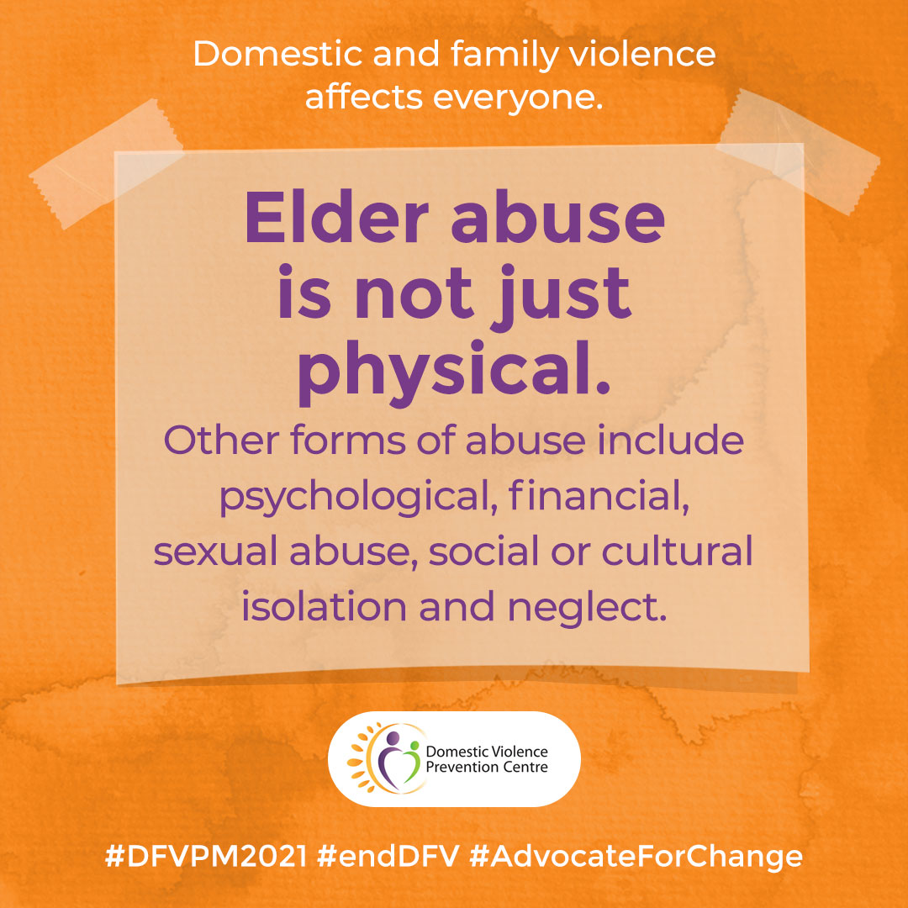

Elderly
Elder abuse is not just physical. Other forms of abuse include psychological, financial, sexual abuse, social or cultural isolation and neglect.
Accompanying text:
Elder abuse is not just physical. Other forms of abuse include psychological, financial, sexual abuse, social or cultural isolation and neglect.
Everyone deserves to feel safe and respected in their relationships.
For more information: https://domesticviolence.com.au/information/information-about-family-violence/#elder
How to get help:
In an emergency phone the police on Triple Zero (000)
For free and confidential advice for anyone experiencing elder abuse or who suspects someone they know may be experiencing elder abuse, call DVPC (9am–5pm, Monday to Friday) on (07) 5591 4222 or call the Elder Abuse Helpline (9am–5pm, Monday to Friday) on 1300 651.
#DVPM2021 #DomesticViolencePreventionMonth #AdvocateForChange

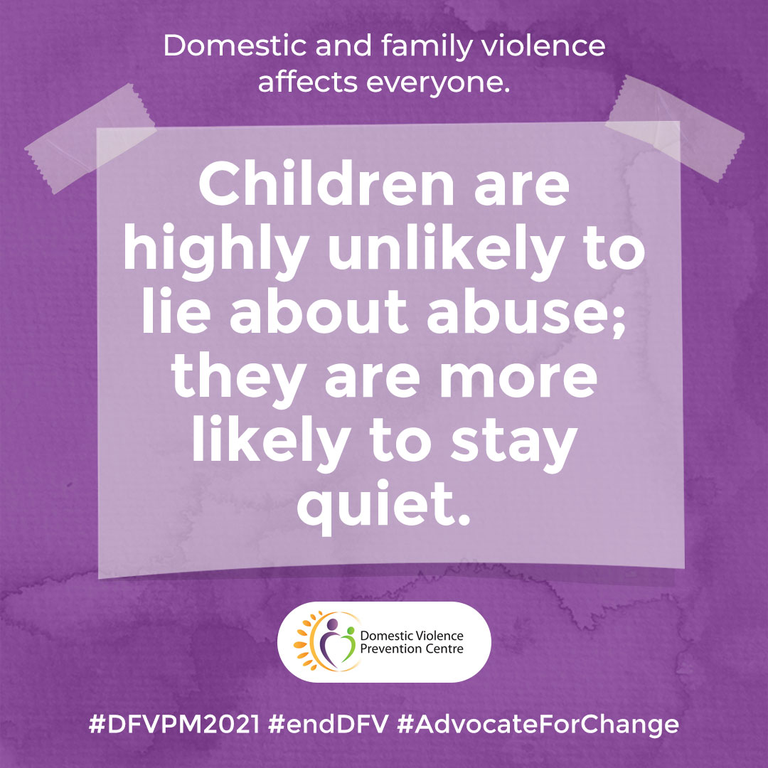

Children and young people
Children are highly unlikely to lie about abuse; they are more likely to stay quiet.
Accompanying text:
A child rarely lies about abuse. A child may change what they've said if they've been pressured or threatened to deny what's happened, or they're afraid of being removed from their family after they’ve told someone about it.
Children and young people who have experienced or been impacted by domestic and family violence can receive support to: help make sense of their experience(s); learn helpful tools and strategies that can assist them with managing and expressing their emotions; and develop an understanding of healthy and positive relationships.
The DVPC Children and Young People’s Service offers appointments with trained Advocates who are skilled and experienced in working with children and young people.
For more information and resources, visit: https://domesticviolence.com.au/getting-help/children-and-young-people/
How to get help:
In an emergency phone the police on Triple Zero (000).
To contact the DVPC Children and Young People’s Service (9am–5pm, Monday to Friday) call: (07) 5532 9000.
If outside business hours, contact the Child Safety After Hours Service Centre on 1800 177 135 (24 hours a day).
#DVPM2021 #DomesticViolencePreventionMonth #AdvocateForChange

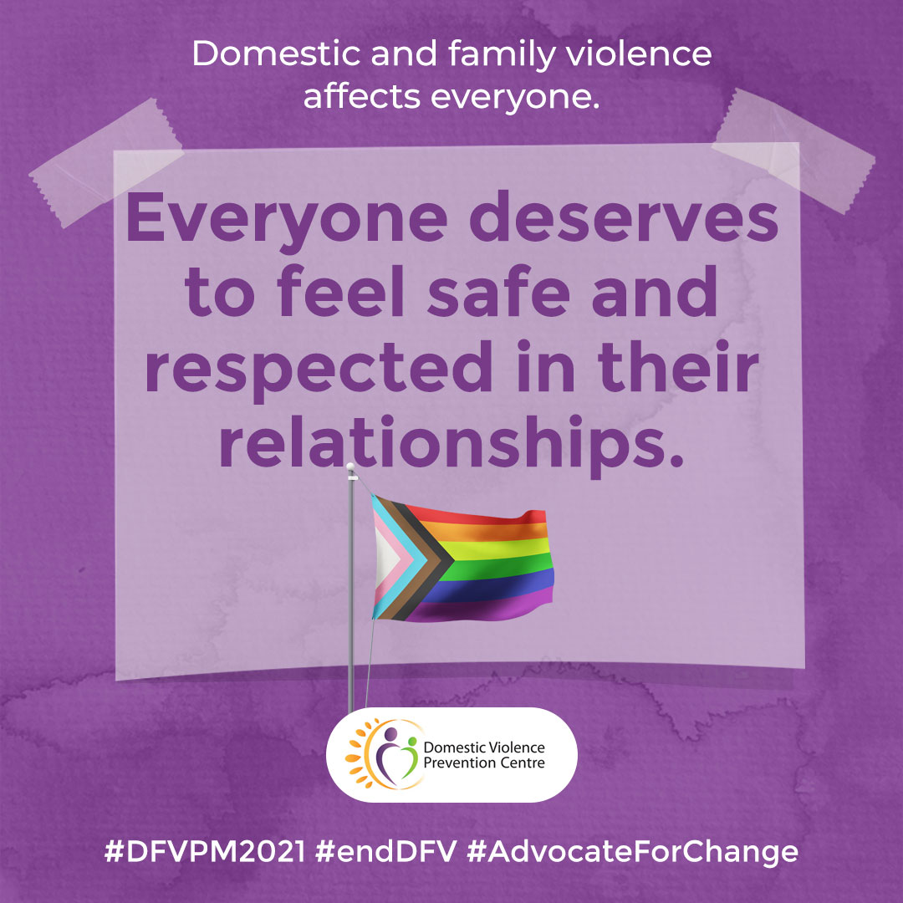

LGBTIQ
Everyone deserves to feel safe and respected in their relationships.
Accompanying text:
Everyone deserves to feel safe and respected in their relationships.
Tactics of power and control particular to same sex relationships include:
- using emotional abuse
- using coercion and threats
- denying, minimising and blaming
- using privilege
- using intimidation
- using isolation
- using children.
For more information, support and resources, visit https://domesticviolence.com.au/information/#lgbtiq
How to get help:
In an emergency phone the police on Triple Zero (000)
Contact the Domestic Violence Prevention Centre Gold Coast for free and confidential counselling, support, information on (07) 5591 4222.
#DVPM2021 #DomesticViolencePreventionMonth #AdvocateForChange

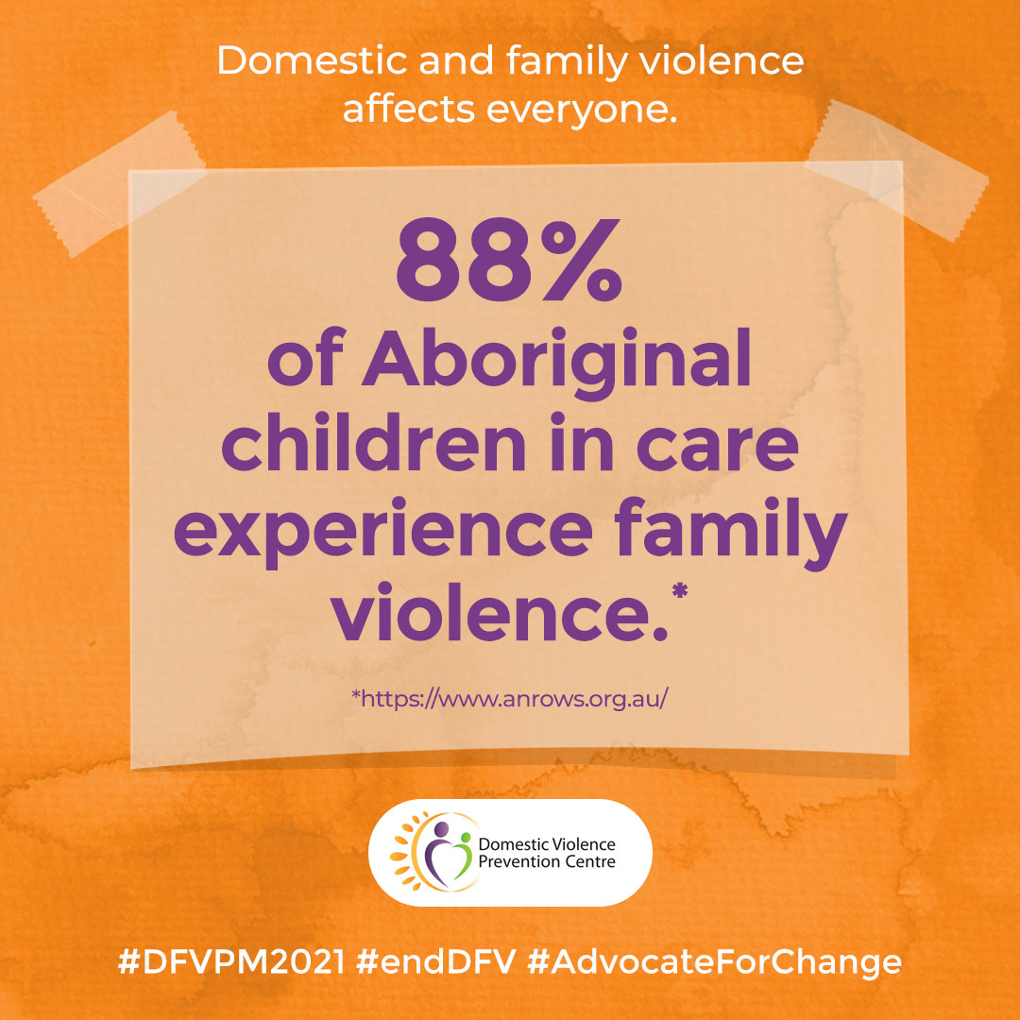

Aboriginal and Torres Strait Islanders
Intimate partner violence contributes an estimated 10.9 percent to burden of disease in Indigenous women aged 18-44 years. This is more than any other risk factor.
Accompanying text:
Intimate partner violence contributes an estimated 10.9 percent to burden of disease in Indigenous women aged 18-44 years. This is more than any other risk factor.*
The close-knit nature of the Aboriginal Community with its kinship networks means that family violence has the potential to affect a wide circle of people. As an Aboriginal woman you may be concerned about shame and the impact speaking about or doing something about the domestic violence on your family and community. Your obligations and loyalties may make it even more difficult to leave.
A specialist Domestic Violence service can provide you with confidential information and support without pressure or judgement about your choices. They can help you work out ways that you and your children can be safer and help you, if you want to, make contact with an Aboriginal support agency.
* Source: 2011 Australian Institute of Health and Welfare Burden of Disease Study (Webster, 2016)
For more information, visit https://domesticviolence.com.au/information/#aboriginal
How to get help:
In an emergency phone the police on Triple Zero (000)
For free counselling, support, information and referral for women and their children who have or are experiencing domestic and family violence, call DVPC (9am–5pm, Monday to Friday) on (07) 5591 4222.
#DVPM2021 #DomesticViolencePreventionMonth #AdvocateForChange

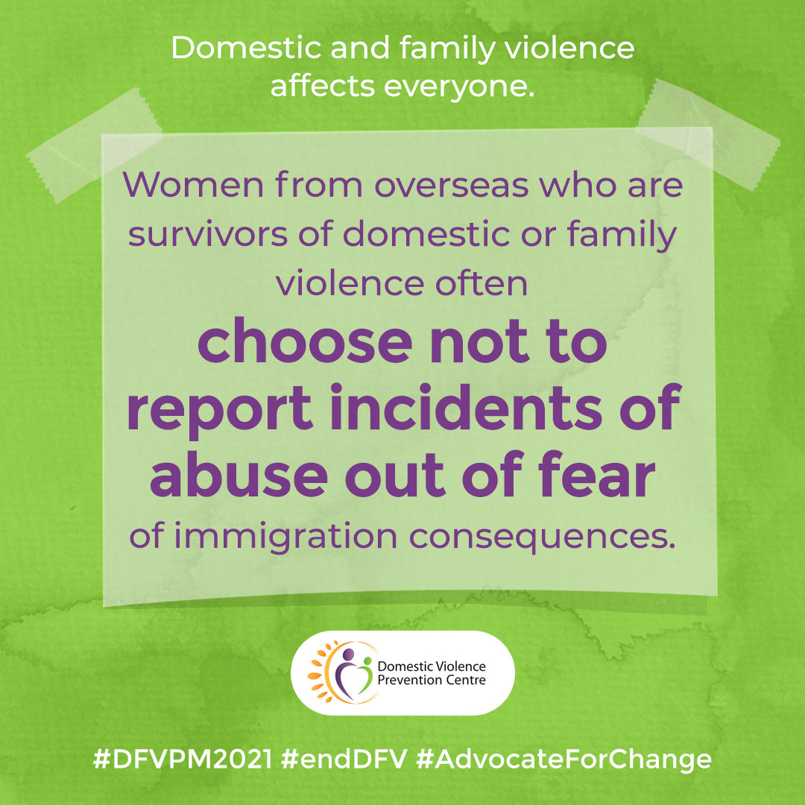

Women from overseas
Women from overseas who are survivors of domestic or family violence often choose not to report incidents of abuse out of fear of immigration consequences.
Accompanying text:
Women from overseas who are survivors of domestic or family violence often choose not to report incidents of abuse out of fear of immigration consequences.
If you came to Australia on a temporary partner or spousal visa and were told that you will be forced to return to your home country if you leave your violent and abusive husband, fiancé or partner – this is not true.
The Migration Act (1958) says that if the marriage or relationship breaks down because of domestic or family violence, then the victim (the person who is being abused) can apply for permanent residency in Australia.
Everyone deserves to feel safe and respected in their relationships.
For more information, support and referral, visit https://domesticviolence.com.au/information/#overseas
How to get help:
In an emergency phone the police on Triple Zero (000)
For free counselling, support, information and referral for women and their children who have or are experiencing domestic and family violence, call DVPC (9am–5pm, Monday to Friday) on (07) 5591 4222.
#DVPM2021 #DomesticViolencePreventionMonth #AdvocateForChange

